**COMPLETELY INSTALLED**

**CARPET SPECIALS**

**INCLUDES:**

**-Carpet**

**-Pad**

**-Installation**

**-Sales Tax**

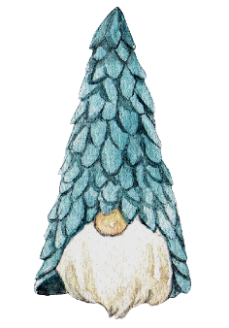

**Includes carpet, padding, professional installation and sales tax all for one low SF price!!**